**Azure Data Factory(Version1)**

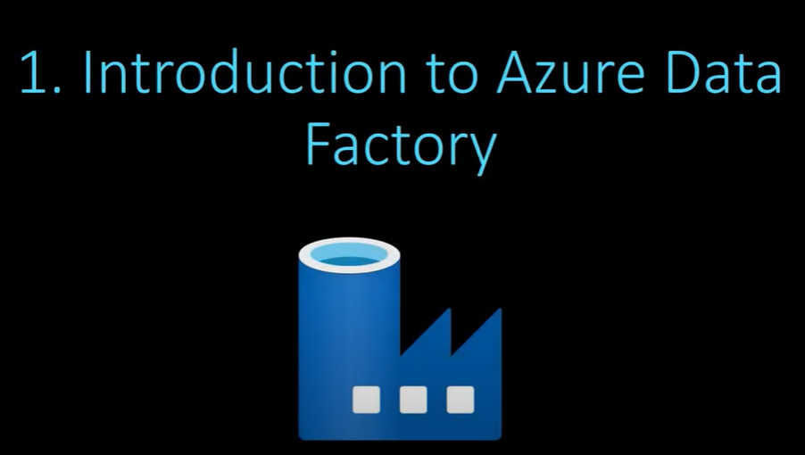

**What is Azure Data Factory (ADF)?**

* + Think of **Azure Data Factory (ADF)** as a **tool** or **service** that
  + helps you move, process, and manage **data** in the cloud,
  + like moving files or organizing documents on your computer.
  + **ADF** is a cloud-based ETL tool.
  + **ETL 🡪 Extract, Transform, and Load**.

**Key Ideas:**

* **Data Movement**:
  + It helps you **move data** from one place to another.
  + **For example**, you might want to move your data from a local computer to a cloud service like Azure.
* **Data Transformation**:
  + Sometimes, the data you move needs to be cleaned or changed into a different format before you can use it
  + (like turning a messy spreadsheet into a tidy table).
  + **ADF** helps you **transform** data to make it more useful.
* **Scheduling & Automation**:
  + **ADF** also allows you to **automate** tasks.
  + **For example**, if you want to move data every night,
  + you can schedule it so ADF does the job without you having to press any buttons.

**ADF** is like a **digital factory** for data.

* + It **moves** data from different places (like your computer or other cloud services).
  + It **processes** or changes data into a useful form.
  + It can **automate** this entire process so you don't have to do it manually every time.

**When is it Useful?**

* + Imagine you have a company with data stored in different places, like:
* Customer data in an **SQL database**,
* Sales data in **Excel files** on your computer,
* Marketing data in **Google Analytics**.

You can use **ADF** to:

* + Collect data from all these places,
* Clean or change the data (if needed),
* Store the cleaned data in a **central location**, like **Azure SQL Database** or **Azure Data Lake**.

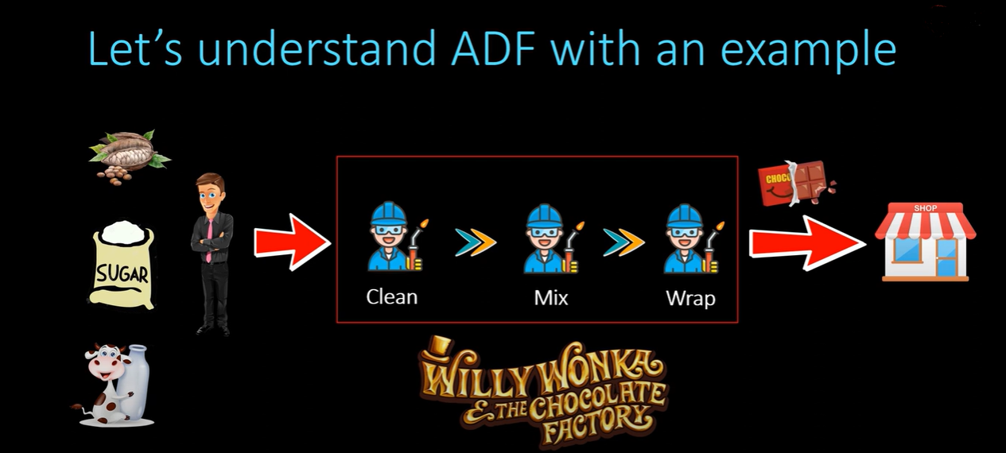

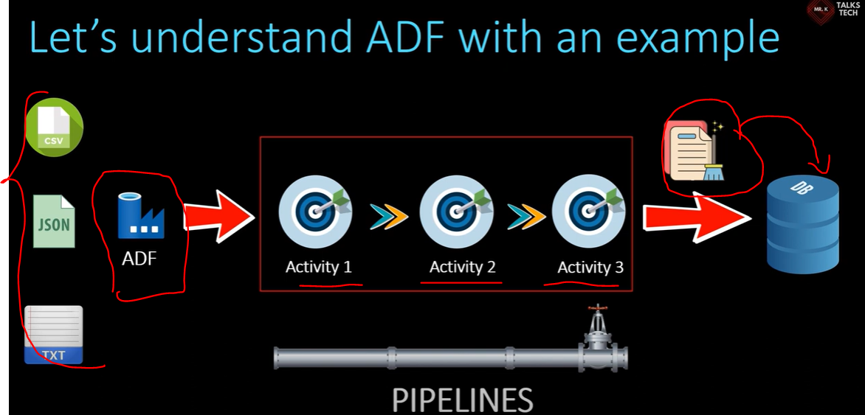

The manager drives all the work but doesn’t do any work.

In the same way, ADF drives all the work.

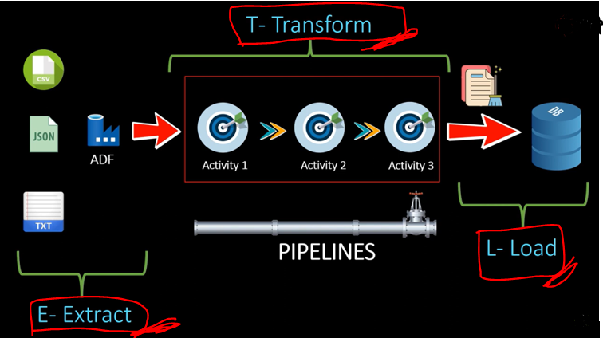

The above process is done by the Data Engineer.

The process below is done by a Data Analyst.

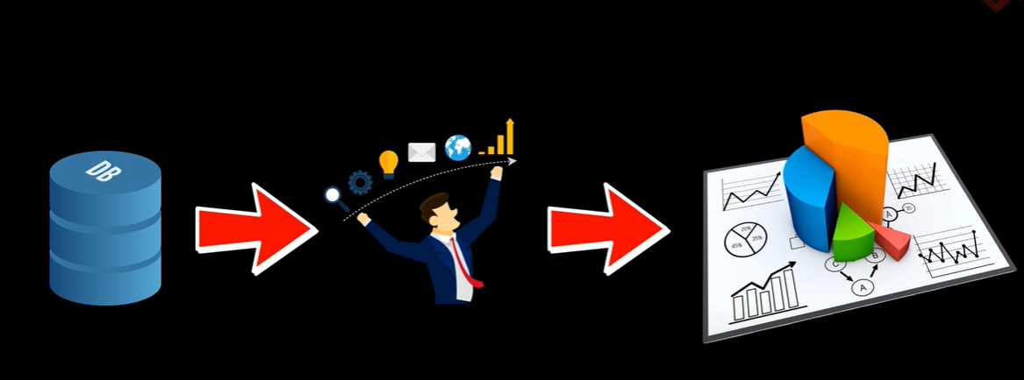

**How to create ADF in Azure Portal:**

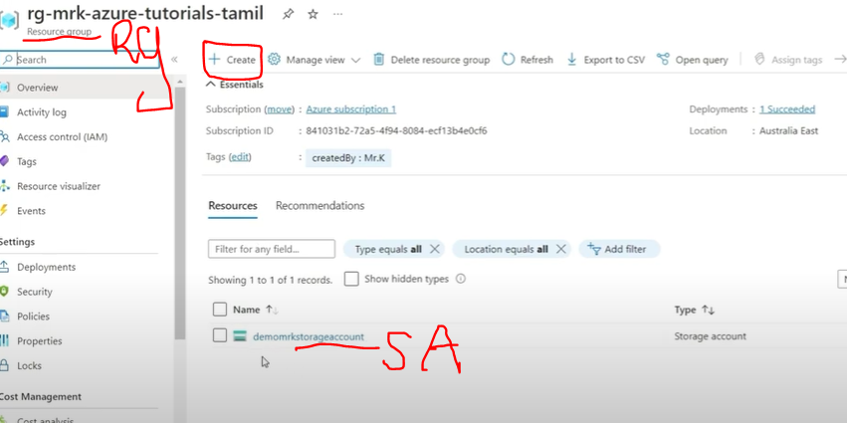 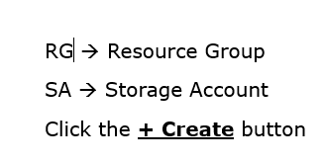

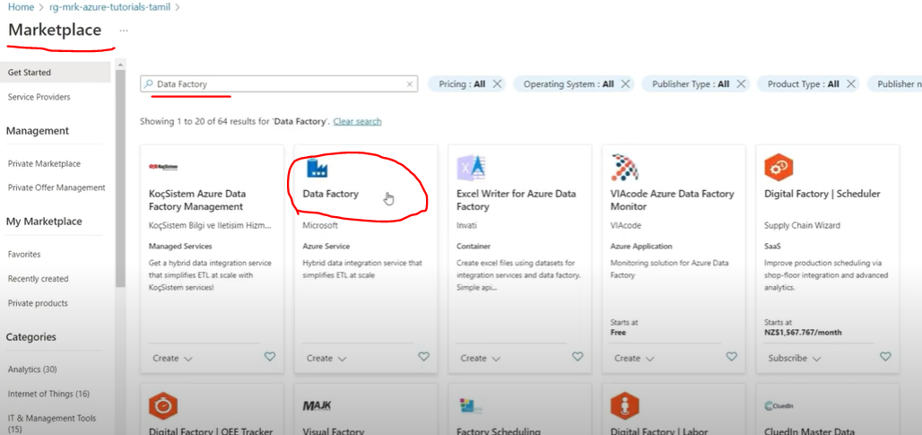

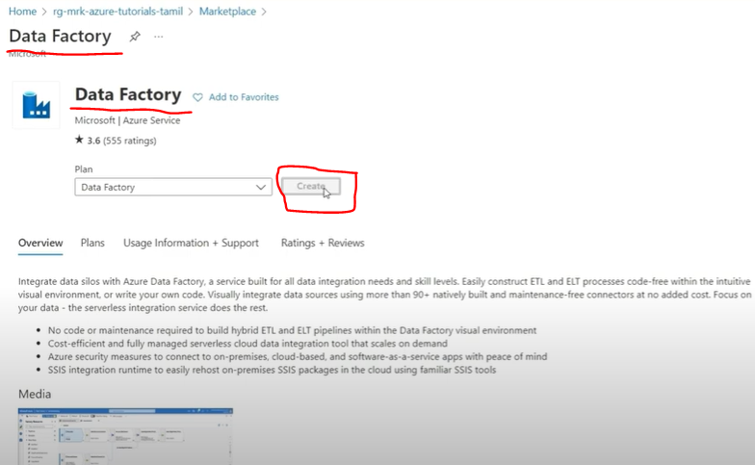

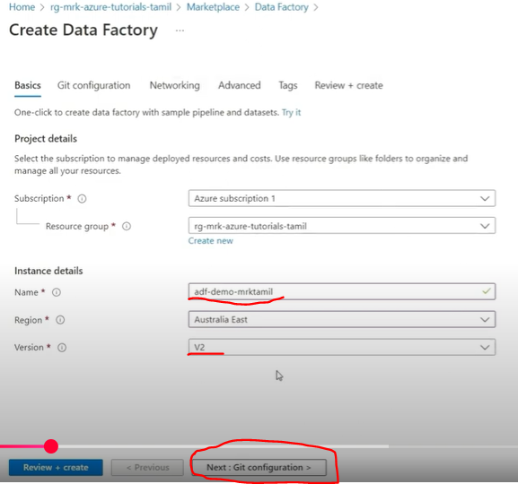

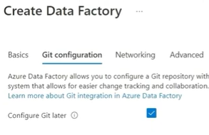 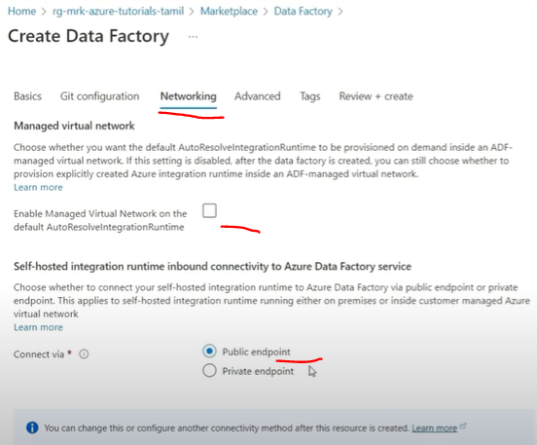

* Just for learning purposes, so not checked the Enable Managed Virtual Network…
* For Security purposes.
* If all activities should be done with Private Networking, then check it.
* This will be provided by Azure, which provides Private networking, and through that, we can access all our activities.

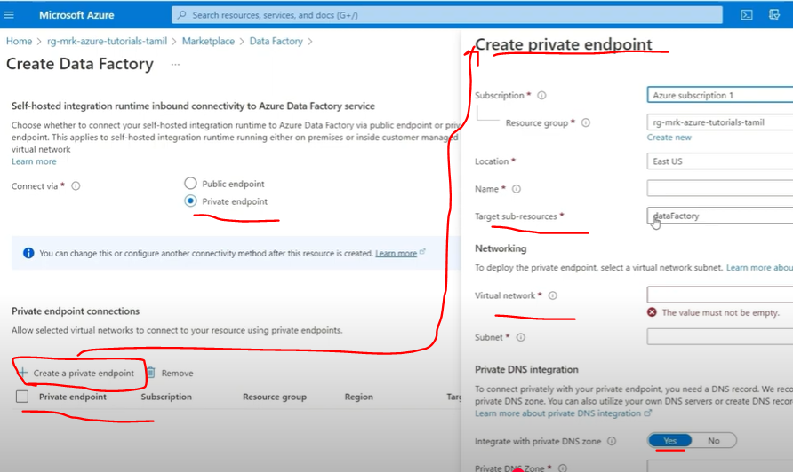

* If we need to choose a private endpoint, we should create our private endpoint.
* But here, the demo is with the public endpoint.
* 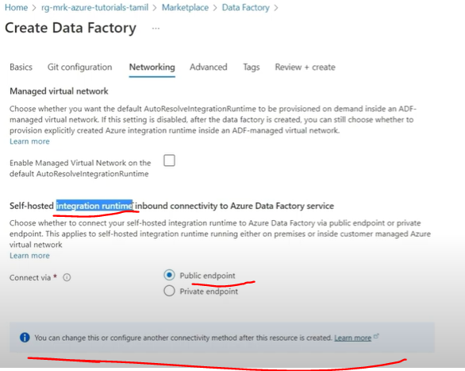

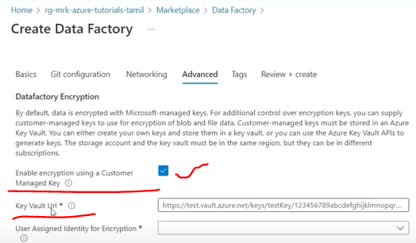

* If we enable this key check box, we should have our key in this key Vault.

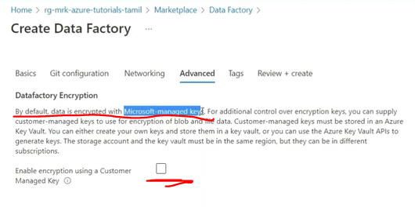

* For a simple one, we can go with the Default Microsoft Encryption
* This default will also provide high security.
* This is also sufficient Security.

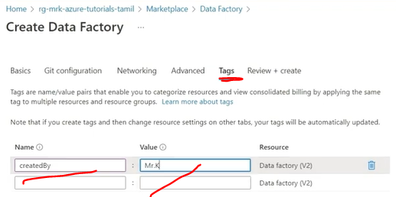

* Used for easy identification of the resource.

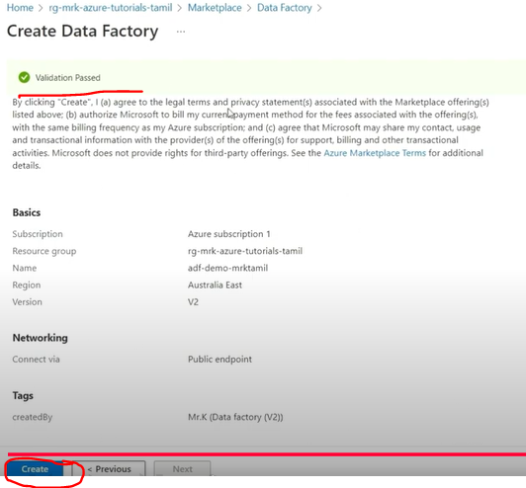

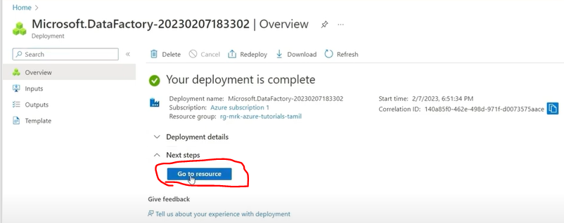

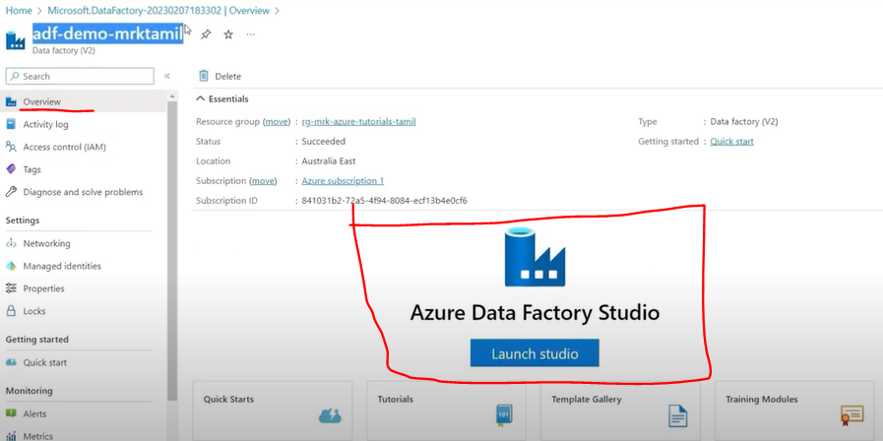

* It directly takes you to the ADF by clicking the Go to resource button.
* More important in this Overview page is Azure Data Factory Studio.
* Click the **Launch Studio** Button.

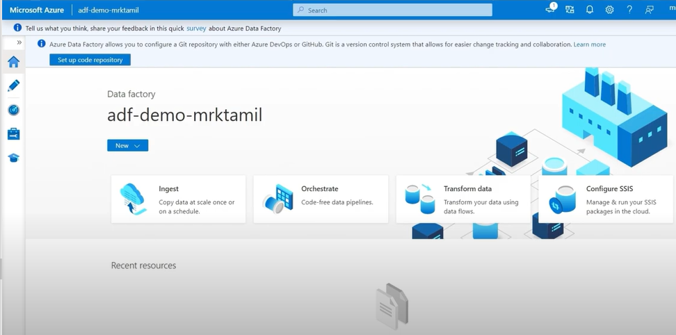

**Azure Data Factory Studio Tour:**

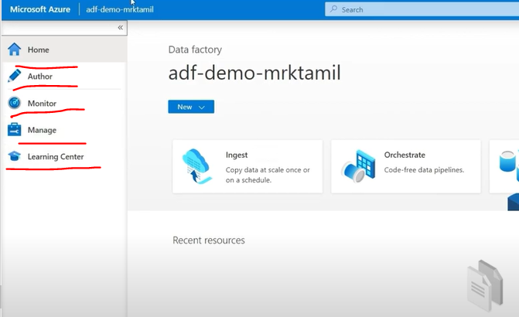

* Mainly, this Home tab is used for quick access to all ADF items.

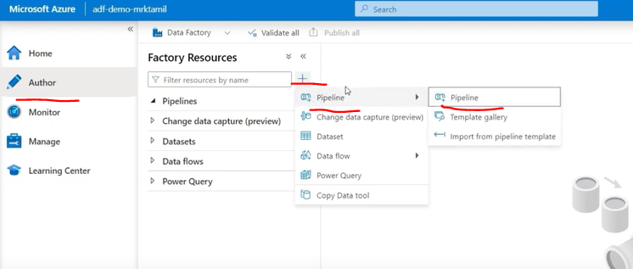

* This **Author tab** is an important one.
  + The Author tab means that developing things are done here.
  + Here only we create all the Pipelines.
  + **Change data capture (preview)** 🡪 This is a newly added feature that shows the keyword preview.
    - It is used to talk about the new data to update or insert.
  + **Data** **flows** 🡪 are mainly used for Data Transformation.
    - UI based Data Transformation.
    - **For Example**, instead of writing complex SQL queries or Python code for joining data,
    - We can use this UI-based data flow.
    - These data flows provide various easy-to-use options like unions, aggregations, and other transformation functions.
    - Simply use these visual tools to transform your data easily.
    - We'll save these data flows for future use too.
  + **Power** **Query** 🡪 Let me tell you about Power Query.
    - If you've used Excel, you know there's a formula bar at the top where you can enter functions.
    - Power Query is similar, but it's a more powerful tool for data transformation.
    - It's typically found in the Author tab, and you can use it to transform your data into different formats.
* If you look at it, most of our development work will happen in this Author tab.
* We'll create ETL pipelines, handle transformations, and manage all these processes right here in the Author tab.
* **Monitor Tab**
  + 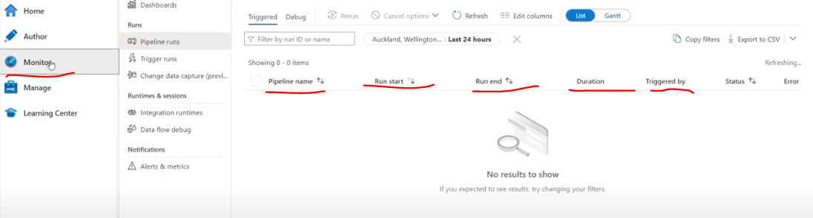
  + Its main purpose is to monitor all your pipeline runs.
    - **For example**, when you create and run a pipeline,
    - You need to monitor it.
    - It's not just about running the pipeline - if it fails, you need to know why it failed.
    - All this information can be found in the Monitor tab.
  + **Pipeline Runs** you can check details like:
    - * - Pipeline name
      * - Start time
      * - End time
      * - Duration
      * - Trigger settings
  + You can monitor the status - whether it passed or failed.
  + Here, you'll find both Pipeline Runs and Trigger Runs.
  + **Trigger runs**. After creating a pipeline, you can set triggers to run the pipeline automatically using Triggers.
  + 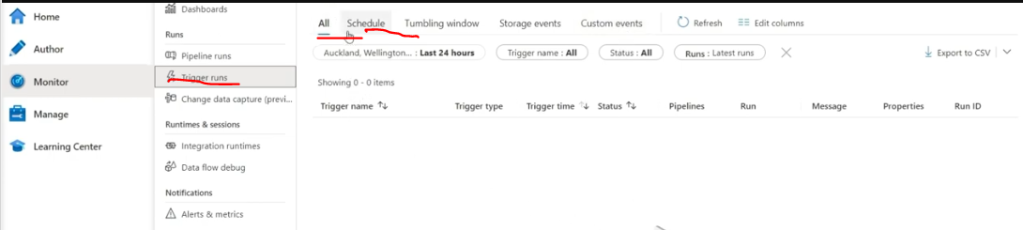
    - **For Example**, if you need a pipeline to run daily at 10 AM, you can create a trigger for that.
    - There are several types of triggers available:
    - - Scheduled triggers (like daily at 10 AM)
    - - Tumbling window triggers
    - - Storage events triggers
    - - Custom triggers
  + **Change Data Capture,** we use it for monitoring here.
    - This is a new feature in the Monitor tab, which is why it's marked as preview.

Then we have **Integration Runtimes**, which is a crucial concept.

* + **Integration Functions:**
    - We can monitor these integration run times now.
    - This is a very important matter.
    - So, for now, you can monitor the integration run time. Just remember to check this in the monitor tab.
  + **Data flow debug:**
    - We have already seen what data flow means.
    - We can monitor that here in the monitor tab as well.
  + **Alerts & Metrics tab.** 
    - This tab allows you to create alerts for different scenarios.
    - **For instance**, if a pipeline fails at 10 AM, you can set up automatic alerts like email notifications so that you can monitor and track it.
    - The **Alerts & Metrics tab** helps you create notifications for pipeline failures.
    - Essentially, while the **Monitor tab helps us track everything**,
    - The **Alerts & Metrics tab specifically handles notifications**.
    - 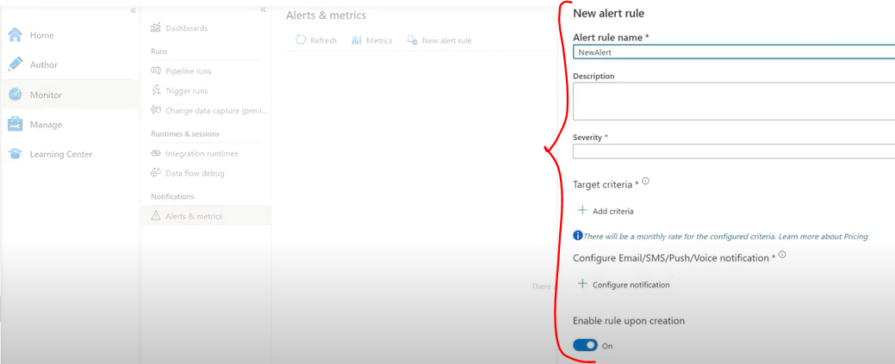
* **Manage Tab:**
  + 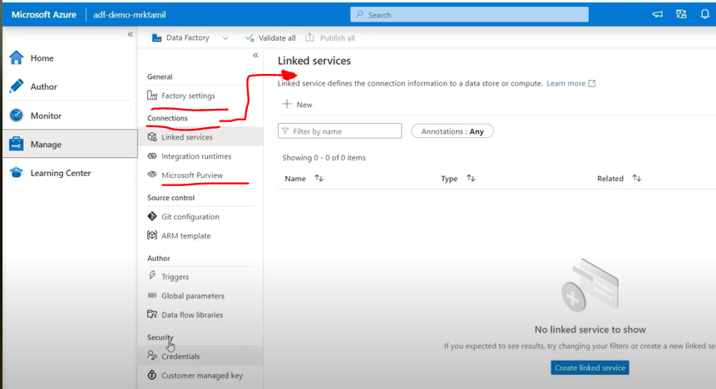
  + The Manage tab is crucial for handling the data factory. configuration settings.
  + So, basically, this Manage tab is mainly used for all configuration settings.
  + All configuration settings required for the data factory are used to manage.
  + For example, here it says factory settings.
  + **Factory Settings:**
    - Used for calculating data factory costs.
    - Manages factory configurations.
    - Since we are using the data factory, some costs will be incurred.
    - The cost settings are used to calculate the cost by **pipeline or by factory**.
    - Factory settings are used to calculate the total cost of the data factory.
    - General settings are used for changing configurations.
    - 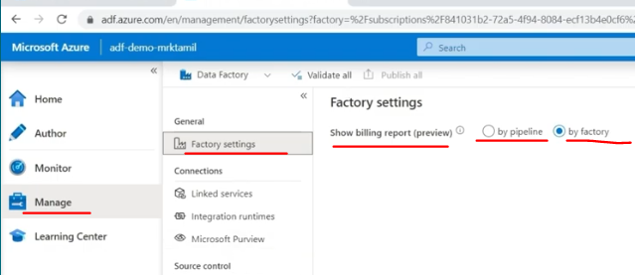
  + **Connections**:
    - Handles link services management
    - **Linked Services** and **Integration Runtime** are essential components
    - **Microsoft Purview:**
    - It's a completely different tool from Azure Data Factory.
    - A separate governance tool
    - While Azure Data Factory is one tool, Microsoft Purview is another separate tool mainly used for governance purposes.
    - You can integrate Microsoft Purview with Data Factory, but they serve different purposes.
    - We integrate with our data factory and manage all these pipelines in the data factory
    - 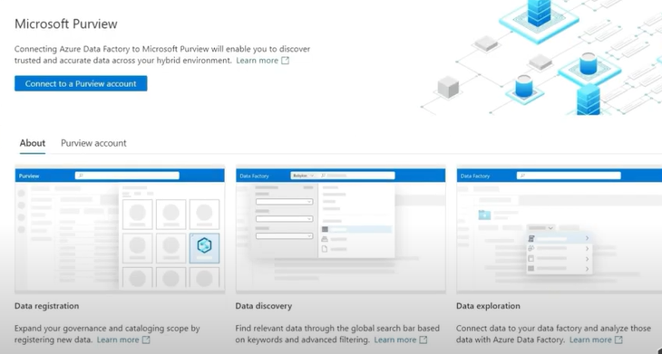
  + **Git** **Configuration:**
    - 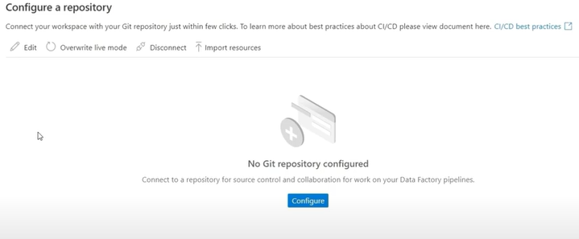 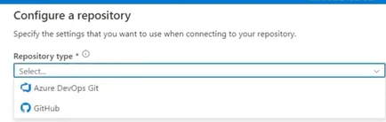
    - Allows integration with Azure DevOps or GitHub
  + **ARM** Template (Azure Resource Manager):
    - 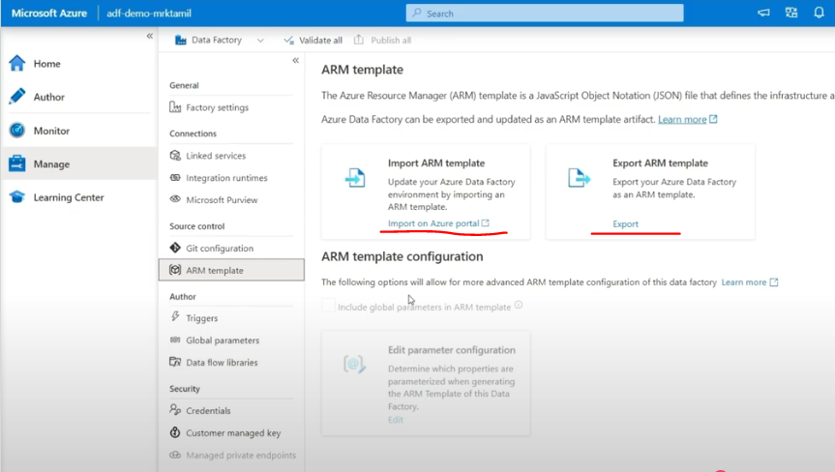
    - When you create any resource in Azure, including a data factory,
    - It creates a JSON format in the backend.
    - You can see this JSON format by exporting the ARM template.
    - Now, if you have another data factory where you have created many pipelines...
    - 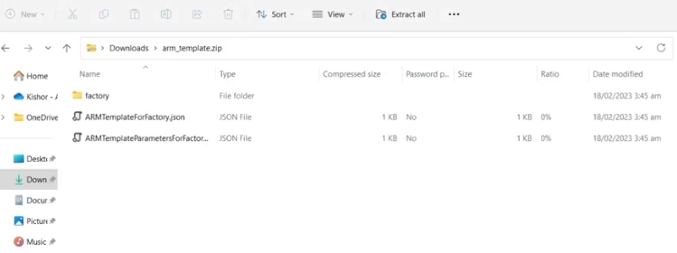
    - When you export, it creates a JSON format of your entire Azure Data Factory
    - Works with JSON format
    - Has Import and Export options
    - Has it been downloaded here?
    - An ARM template has been downloaded.
    - Now, when I go here, to the development location, you can see that the JSON structure has been created.
    - So, basically, this JSON structure is equal to this data factory.
    - So, if you export this data factory and use this option to import, you'll get an exact copy of that data factory here.
    - Similarly, vice versa.
    - So, everything here, if you want to move to that data factory, you see,
    - In this data factory, using this export ARM template, once you download this file template and import it into that data factory,
    - You'll get an exact copy there.
    - So basically, this ARM template...
    - **An ARM template is - everything we create in Azure Data Factory is created as a JSON structure in the backend.**
    - **So, this JSON structure is what we call an ARM template.**
    - Works both ways - import and export give you identical configurations
  + **Triggers**,
    - 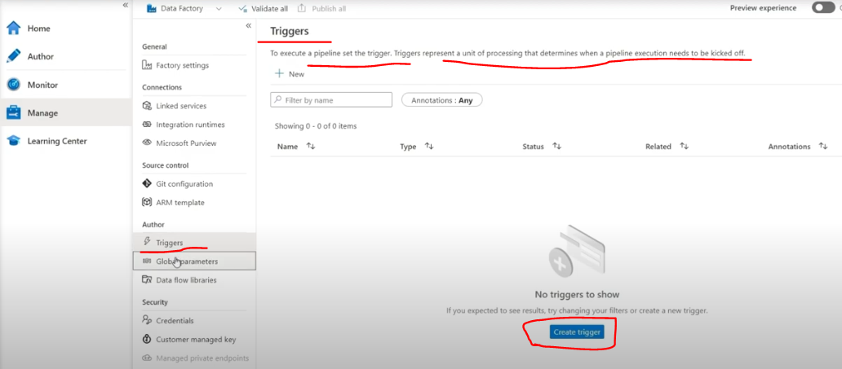
  + **Global Parameters:**
    - This is like a variable.
    - If we need to create a parameter, we can use it in all pipelines.
    - This is similar to how we use global variables in programming languages.
    - We can create these parameters and use them in pipelines.
    - 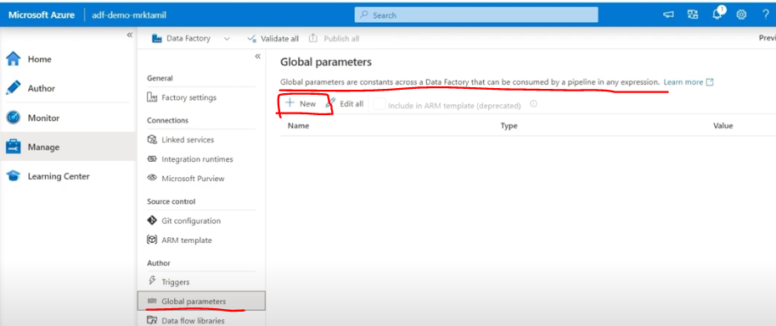
  + **Data flow libraries**
    - 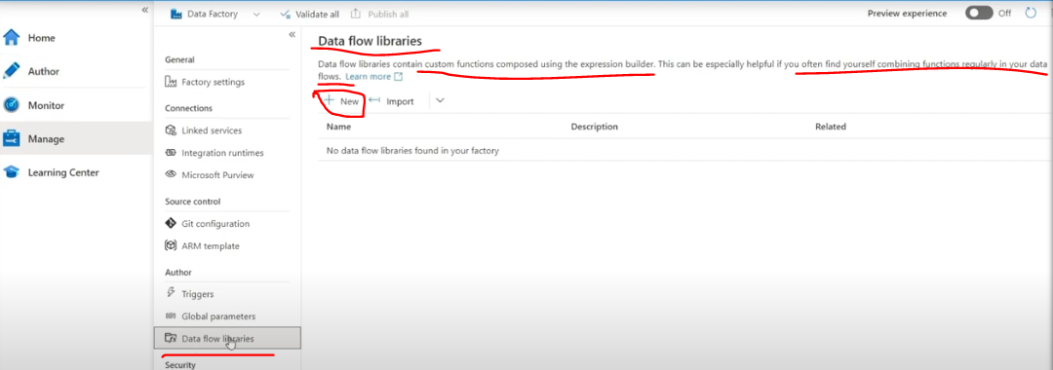
    - We saw what dataflows are, right?
    - We called it a UI-based data transformation tool.
    - Similarly, you can create libraries in this.
    - **For example**, if you have custom functions that you need to use for this purpose,
    - you can either **create new custom functions or import existing ones**.
    - These libraries can be used in the data flow author tab or during data flow development when you're creating data flows.
  + There are two things related to security.
  + One is credentials, and another is Customer managed key.
  + **Credentials:**
    - 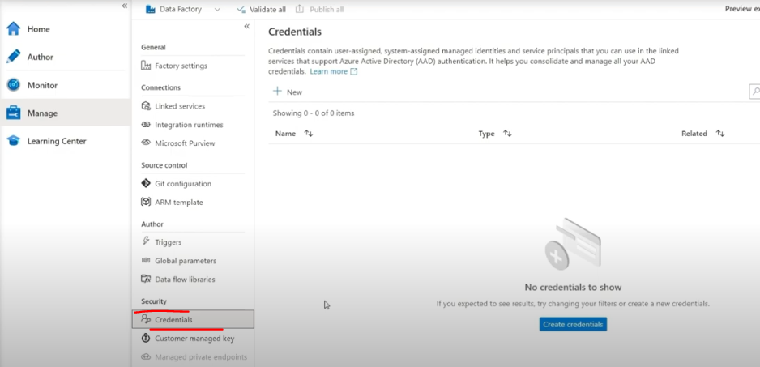
    - Credentials are related to managing identity and service principles.
    - If you want to create credentials related to security and use these credentials to connect with multiple sources,
    - You can create these credentials.
    - This is more into the security thing.
    - We don't have to worry about this now.
  + **Customer managed key:**
    - We saw this before when we were creating the data factory.
    - Which key should we use to encrypt?
    - We used the Microsoft encryption key as the default.
    - If you want to use a key to encrypt data, you can add that key here.
    - We don't have to worry about this now. This is more into the security side.
* **Learning Center tab:**
  + 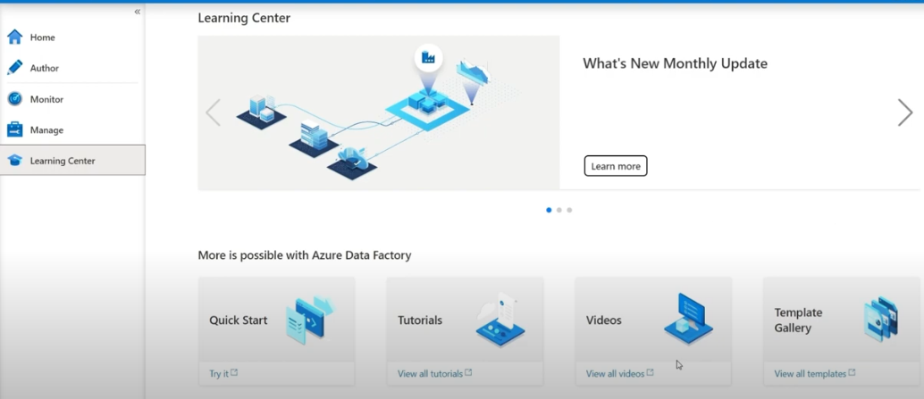
  + The Learning Center is basically to learn more about Azure Data Factory.
  + It contains:
    - Videos
    - Tutorials
    - Quick start guides
    - Instructions on how to use Azure Data Factory
    - Templates for various tasks

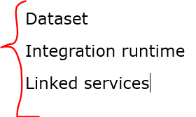 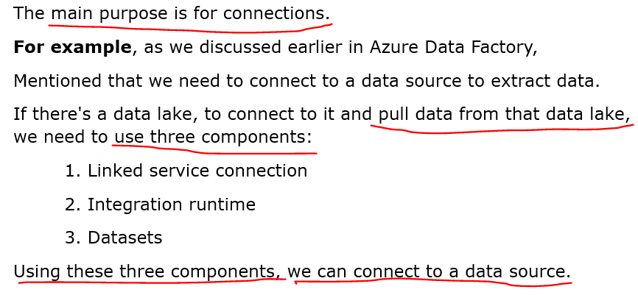

**Integration Runtime, Linked Service and Datasets:**

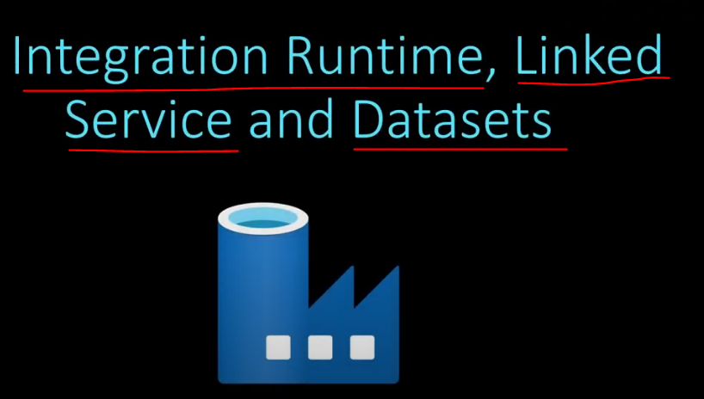

* What is **Integration Runtime**?
  + Integration Runtime is a compute infrastructure for data integration.
  + Data Factory is a main tool used to integrate with data sources.
  + To integrate with a data source, we need a computer, and Integration Runtime is a concept used for this integration.
  + **For example**, when a data factory needs to connect with another data source,
  + Integration Runtime provides the necessary compute power to make this connection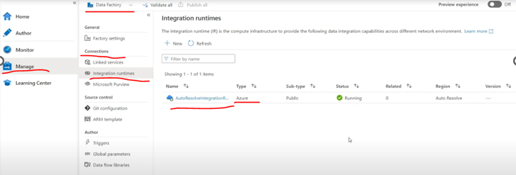
  + 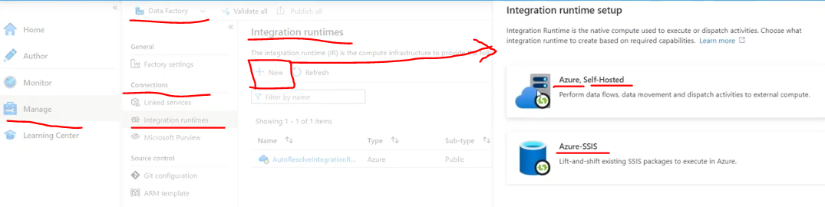
  + There are three types of Integration Runtime:
    - 1. **Azure Integration Runtime 🡪** Used for cloud-based tools.
    - 2. **Self-hosted Integration Runtime 🡪** Used for on-premise data sources.
    - 3. **SSIS Integration Runtime 🡪** Used for moving SSIS packages to the cloud.
  + **Azure Integration Runtime**
    - When we need to integrate Data Factory with any cloud-based data source,
    - We use **Azure Integration Runtime** to **connect with that data source**.
    - **For example**, let's say we want to connect Data Factory with Data Lake.
    - We all know Data Lake is in Azure – Here talking about **Azure Data Lake**.
    - It's a cloud-based tool.
    - So, when Data Factory needs to connect with Azure Data Lake, we need Azure Integration Runtime.
    - How the Integration runtime will be in Azure IR is shown below.
    - 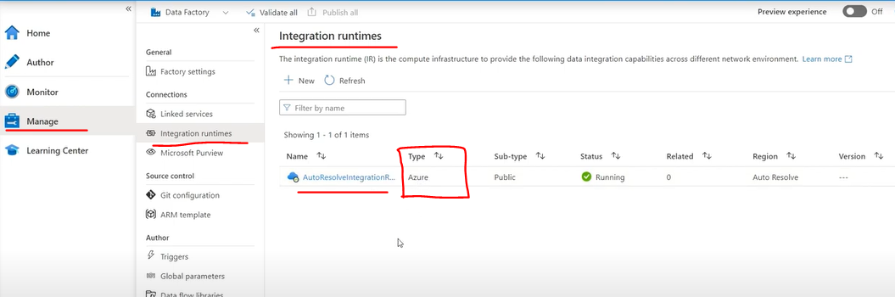
    - The above screenshot is the **Azure IR screen**.
    - 
  + **Self-hosted Integration Runtime**
    - It's used when a **data source is on-premise** or in a **private network.**
    - **For example**, consider an on-premise SQL database - 'on-premise' means it's not in the cloud,
    - but has its separate infrastructure and network with no cloud connection.
    - To **integrate Data Factory** with such an **on-premise data source**, we need a **self-hosted Integration Runtime**.
    - This is installed in the on-premise network, **allowing Azure Data Factory to access the on-premise data source**.
  + **SSIS Integration Runtime**
    - SSIS Integration Runtime is related to SQL Server packages that are on-premises.
    - We can use this **integration runtime to move these SSIS packages to the cloud (Azure) and execute them there**.
  + **The main types used are Azure IR and Self-hosted IR.**
* What is a **Linked Service?**
  + Link Service is like a connection string that helps connect to any data source.
  + **Basic Requirements:**
    - Needs Integration Runtime (like computer power)
    - Connection details for the data source
  + **Key Features:**
    - ADF has 85+ built-in link service connections
    - Supports both SQL and NoSQL databases
    - New connectors are added regularly (in Azure by Azure)
  + **Important Points:**
    - We need an Integration Runtime to create a Linked Service.
    - 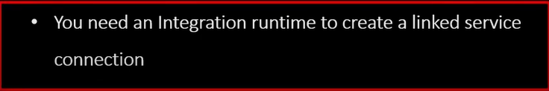
    - Each data source needs specific connection details
    - **Example:** SQL database needs connection string, username, password
  + **For example**, ADF has pre-built link service connections to connect to a data lake or SQL database.
  + 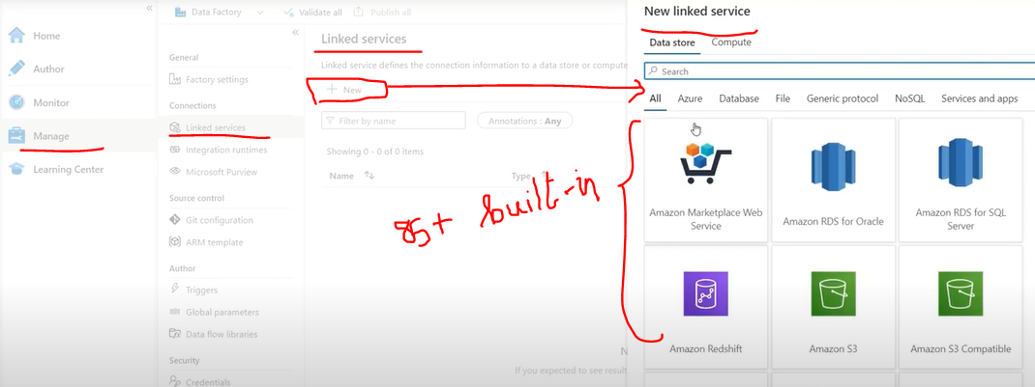
  + 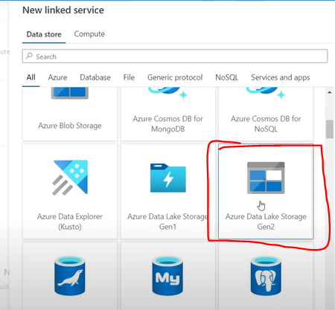Click the **Continue** button
  + 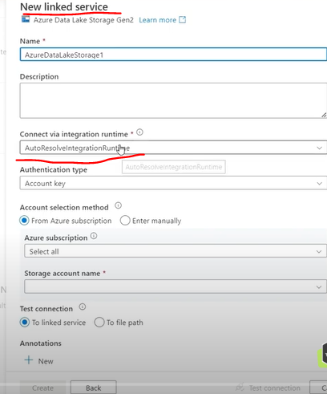
  + We should have an Integration runtime, then only we can create the new linked service.
* What is a **dataset?**
  + 
  + 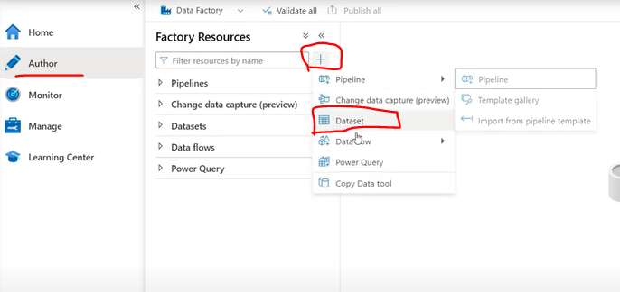
  + 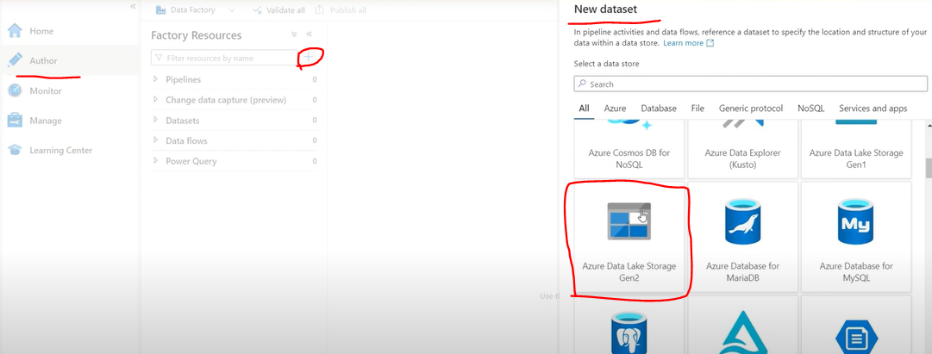 Click the **Continue** button
  + 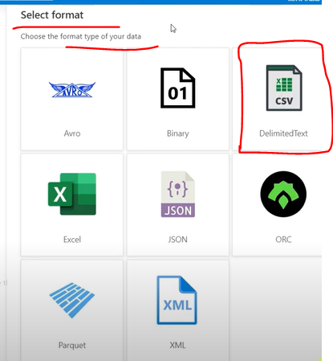Click the **Continue** button.
  + 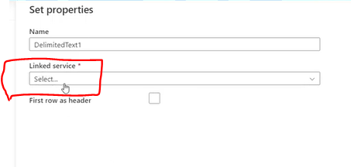
  + A linked service is mandatory to create a Dataset.
  + **Datasets define the structure or format of data**.
  + Here's how it works in sequence:
    - **Prerequisites**:
      * Integration Runtime (compute power)
      * Link Service Connection (connection details)
    - **Key Points about Datasets**:
      * They define how data is structured
      * Cannot be created without a Link Service Connection.
      * Works as a format definition layer
    - **Think of it as a three-step process**:
      * **First 🡪** Integration Runtime provides compute power.
      * **Second 🡪** Link Service provides connection details.
      * **Third 🡪** The Dataset defines how the data is structured.
  + 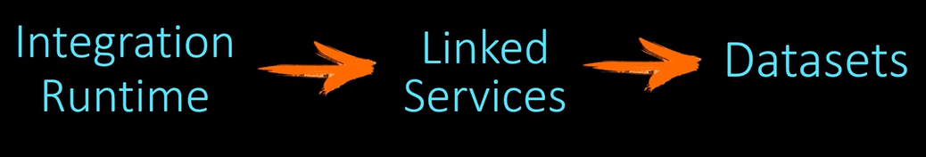
  + Example of the Above:
  + **Data Movement Process in Azure Data Factory**:
  + 
    - **Basic Concept:**
      * Copy data from **Source** (Azure Data Lake) to **Destination** (Azure Data Lake)
      * Use **Azure Data Factory as the tool** for this process
  + 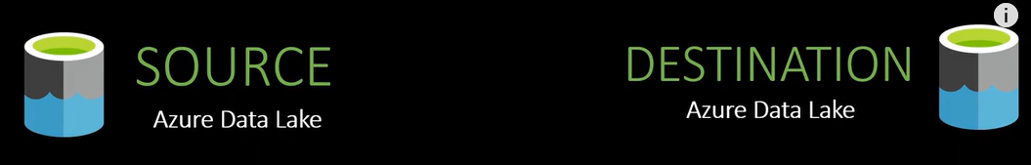
    - **Required** **Steps**:
      * **For Source Connection**:
        + Integration Runtime (Azure IR because the source is cloud-based)
        + Link Service (Data Lake Gen2 connection)
        + Dataset (CSV format structure)
      * **For Destination Connection:**

Same steps as source:

Azure Integration Runtime

Link Service for Data Lake

Dataset configuration

* + 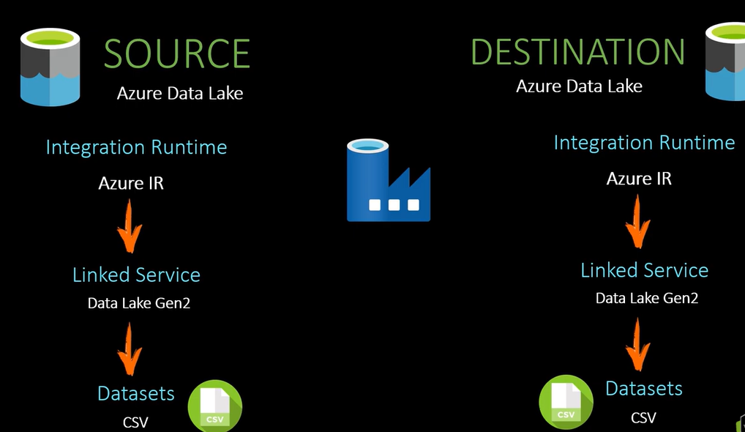
    - Why Azure Integration Runtime?
      * Both source and destination are Azure cloud products
      * Azure IR is best suited for cloud-to-cloud connections
  + 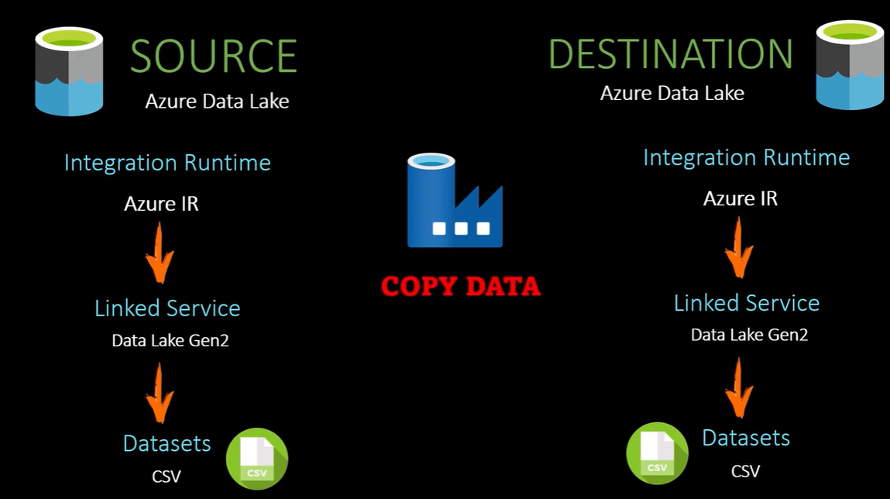
  + Final Step - **Copy Activity**:
  + 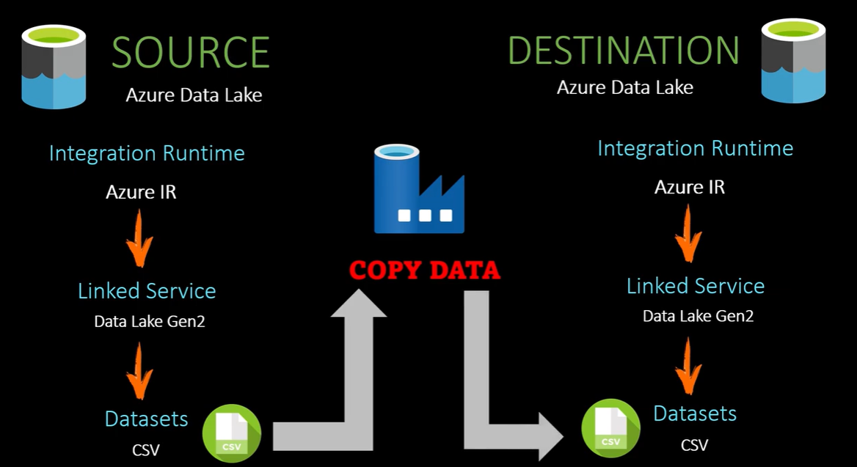
    - What we have ready:
      * Source Dataset
      * Destination Dataset
    - How Copy Activity works:
      * It's the tool that moves data from source to destination
      * In Copy Activity, we need to:
        + Select the source dataset in the 'Source' section
        + Select the destination dataset in the 'Destination' section
  + This completes the data movement setup in Azure Data Factory.
  + **Example:**
  + 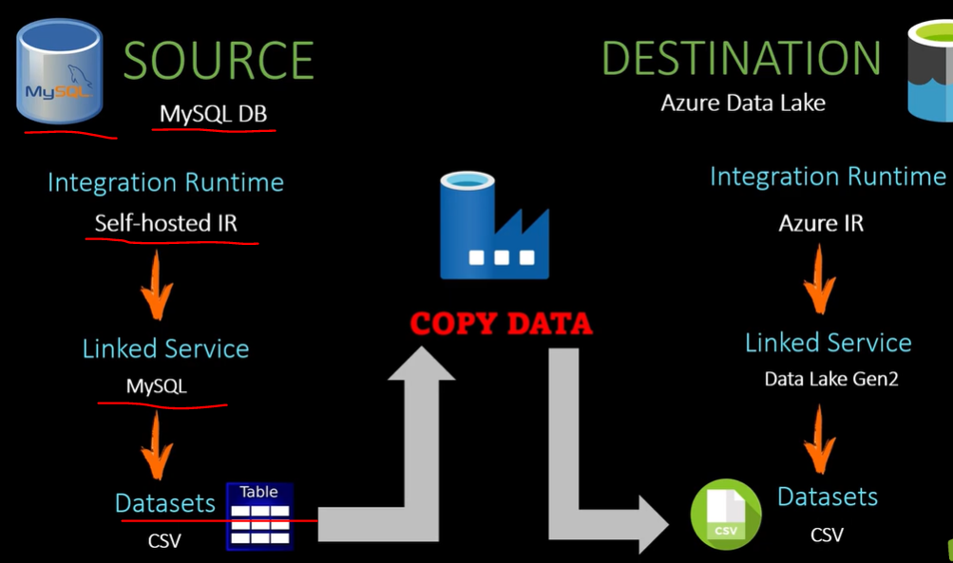
  + Changes needed when the source is an On-premises MySQL Database:
    1. **Integration Runtime Change**:
* Replace Azure IR with Self-hosted IR
* Required because the source is an on-premises database
  + 1. **Link Service Change:**
* **Use MySQL Link Service instead of Data Lake**
* Available as a built-in connector in Azure Data Factory
* Must use a Self-hosted IR for connection
  + 1. **Dataset Change:**
* **Source**: Use the Table format instead of CSV
* **Destination**: Keep CSV format in Data Lake (no changes needed)
  + **Key Point:**
* Self-hosted Integration Runtime is crucial when connecting to on-premises databases.
  + 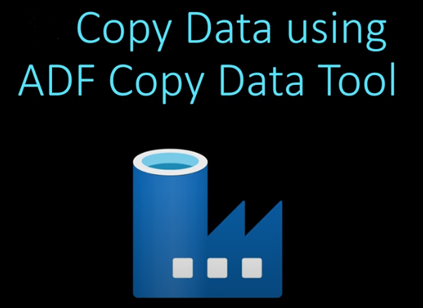
  + 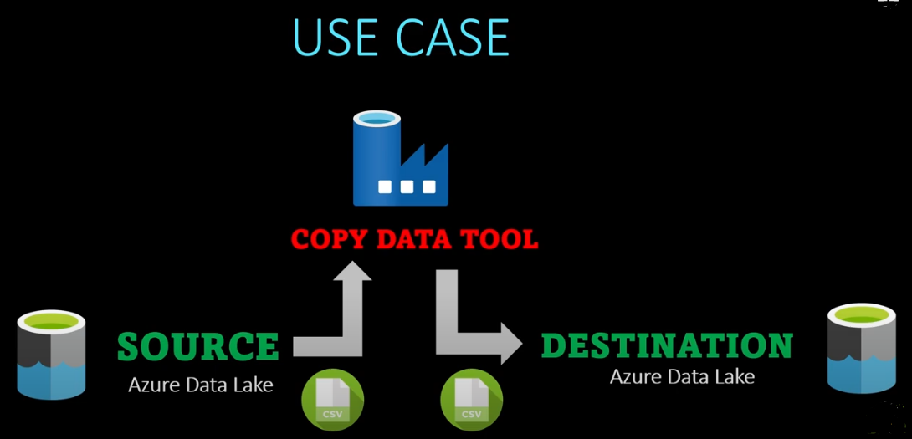
  + 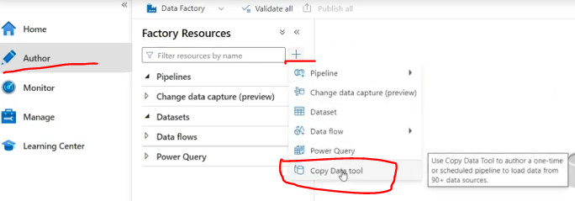
  + 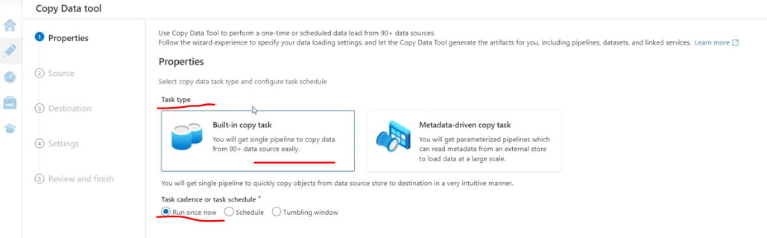
  + 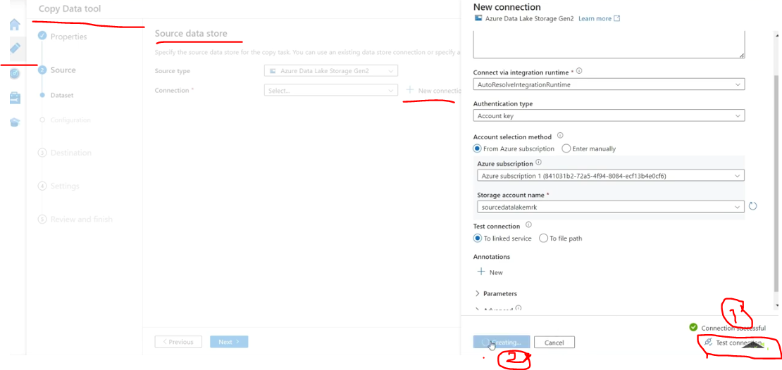
  + 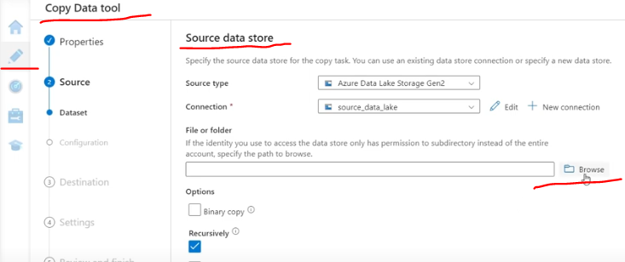
  + 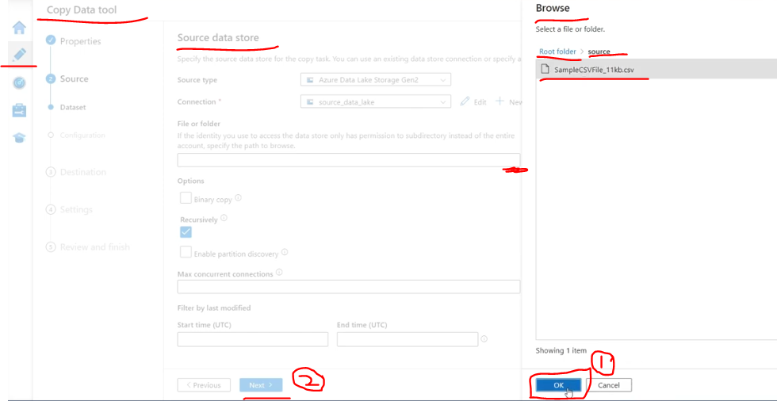
  + 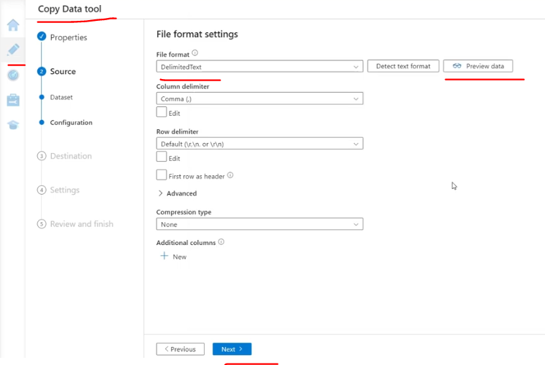
  + 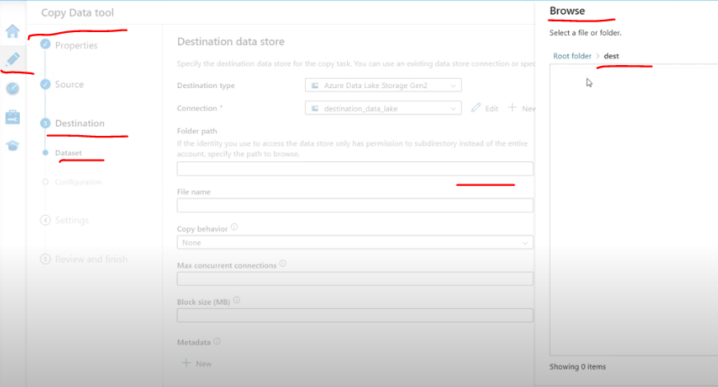
  + 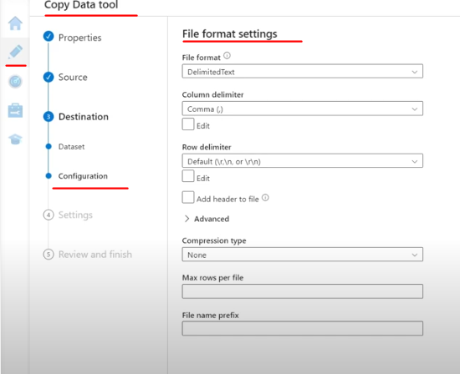
  + 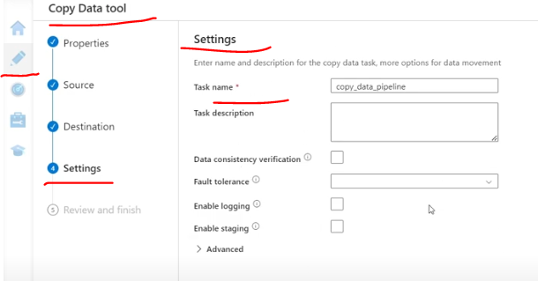
  + 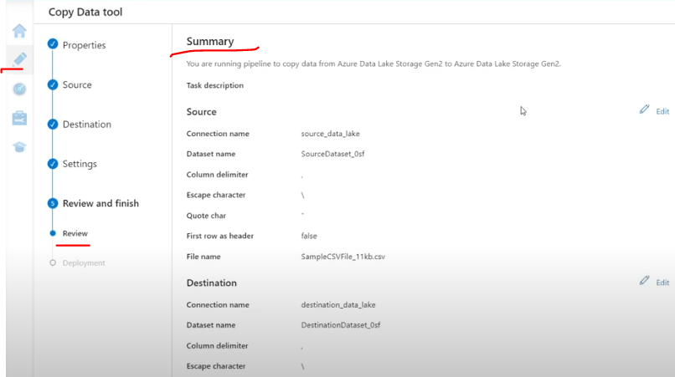
  + 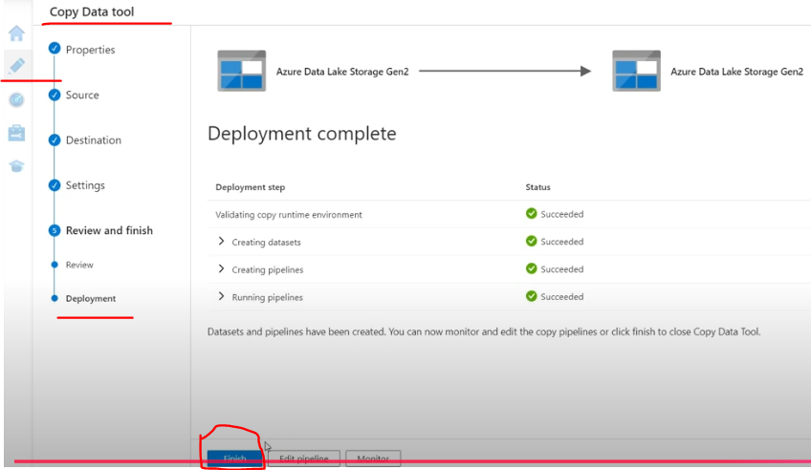
  + 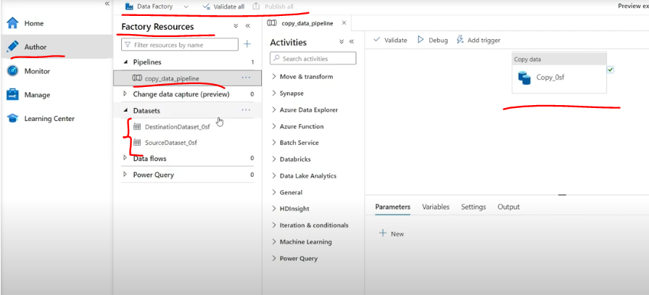
  + 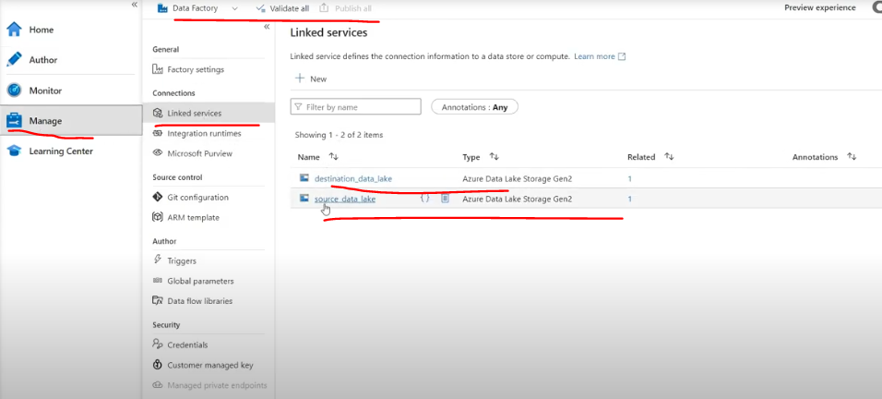

**Triggers in Azure Data Factory (ADF)**

* 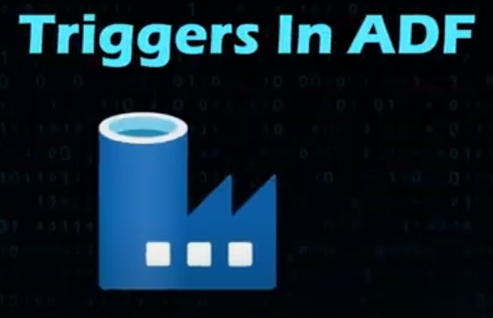
* In Azure Data Factory, a trigger is a mechanism that starts an Azure Data Factory pipeline automatically at a specified time or when a specific event occurs.
* **Triggers automate pipeline execution based on schedules or specific events.** 
  + Already, we created a pipeline from scratch using Azure Data Factory. That pipeline copied a CSV file from the source to the destination.
  + However, note that we ran that pipeline manually.
  + **Instead of running the pipeline manually using the debug option, we can automate it using triggers**.
* 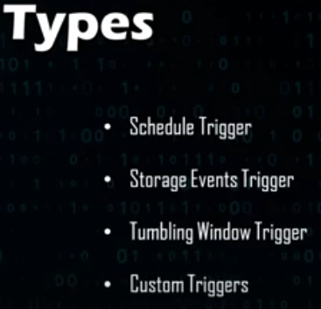
* There are **three main types of triggers**
  + **Schedule Trigger**
    - A Schedule Trigger allows you to schedule when your pipeline should run.
    - You can schedule it to run:
      * Daily (once a day)
      * Hourly (once every hour)
      * Monthly
      * Weekly
    - Let's see how we can set up and configure a Schedule Trigger in the Azure portal.
    - Basically, we can schedule when the pipeline should run using Schedule Triggers.
    - We can configure this using the Azure Data Factory workspace.
* Basically, **a trigger is a concept that explains how to run a pipeline automatically instead of manually**.
* Azure Data Factory has different types of triggers, which we'll look at individually.

Below are done with Prinyanka

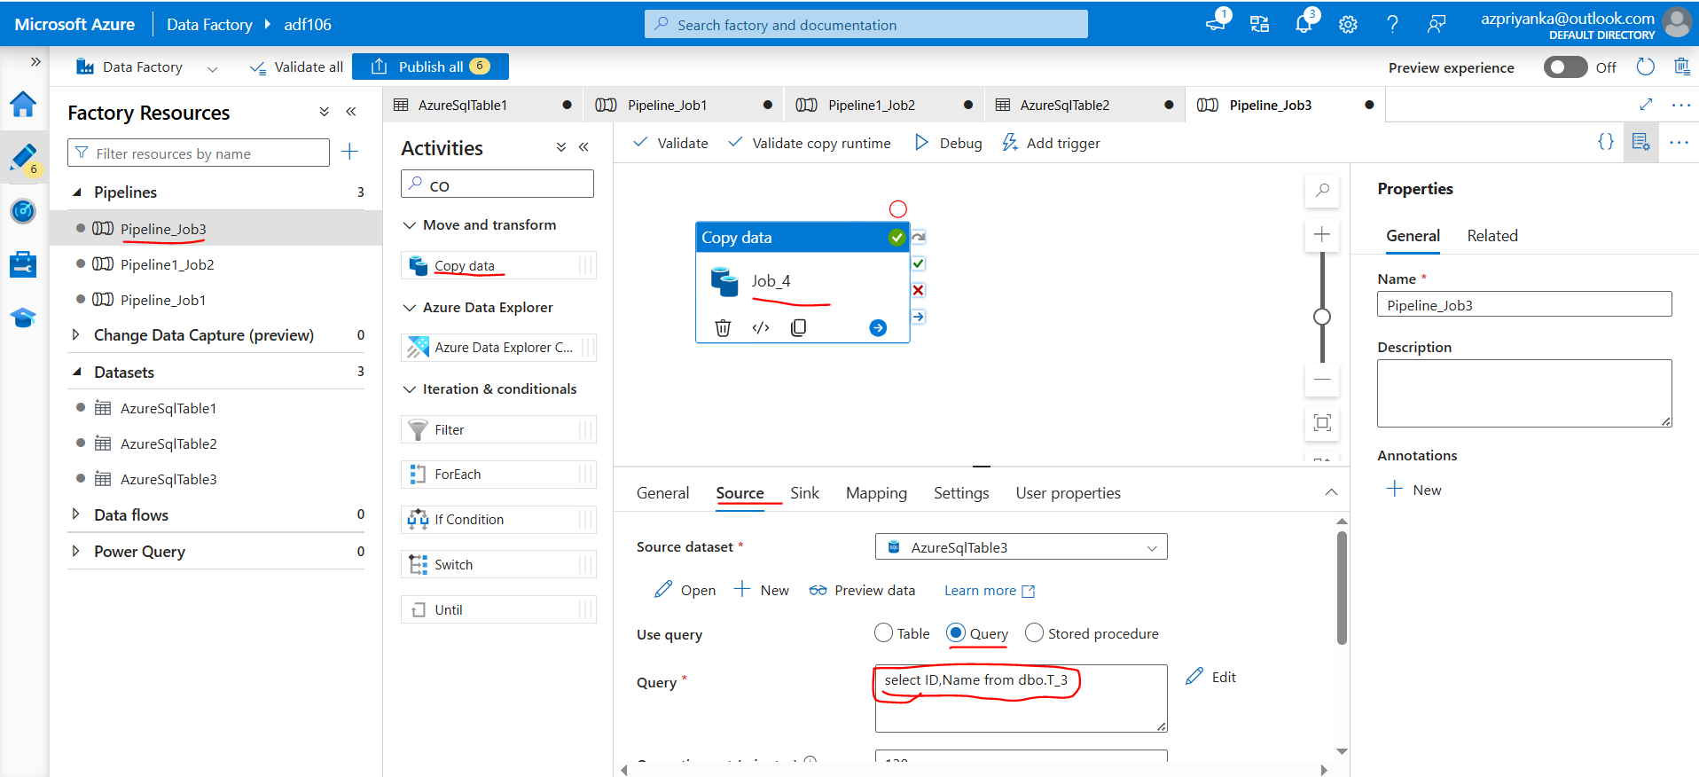

Source has 3 columns(ID,Name,City)

Destination has only 2 columns.So If we copy,it throws error.

We have two options.

1.Mapping(Tab)

2. Query (Inside Source Tab)

